CREATE TABLE log_table4 (user_id VARCHAR2(30), logon_date DATE);

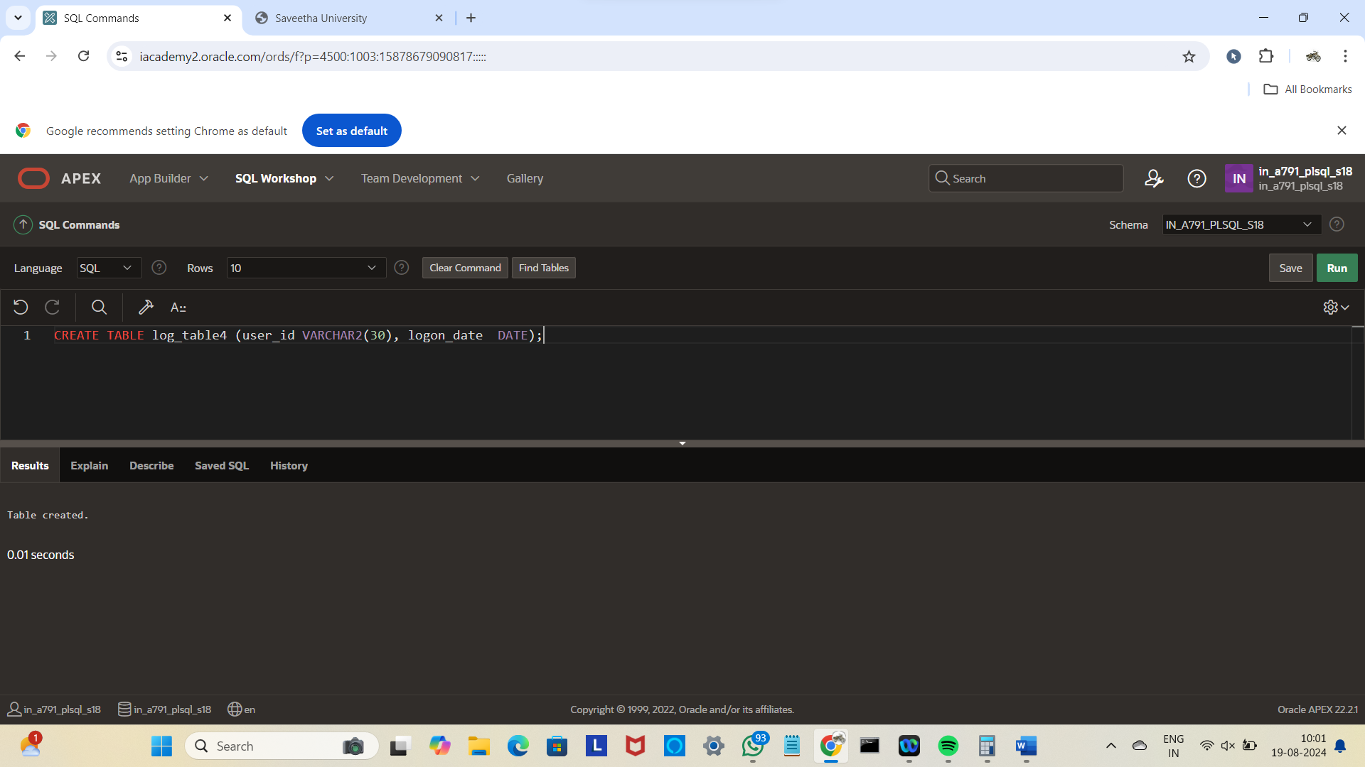

CREATE OR REPLACE TRIGGER log_sal_change_trigg1

AFTER UPDATE OF DEPARTMENT_NAME ON DEPAR

BEGIN

INSERT INTO log_table4 (user_id, logon_date)

VALUES (USER, SYSDATE);

END;

/

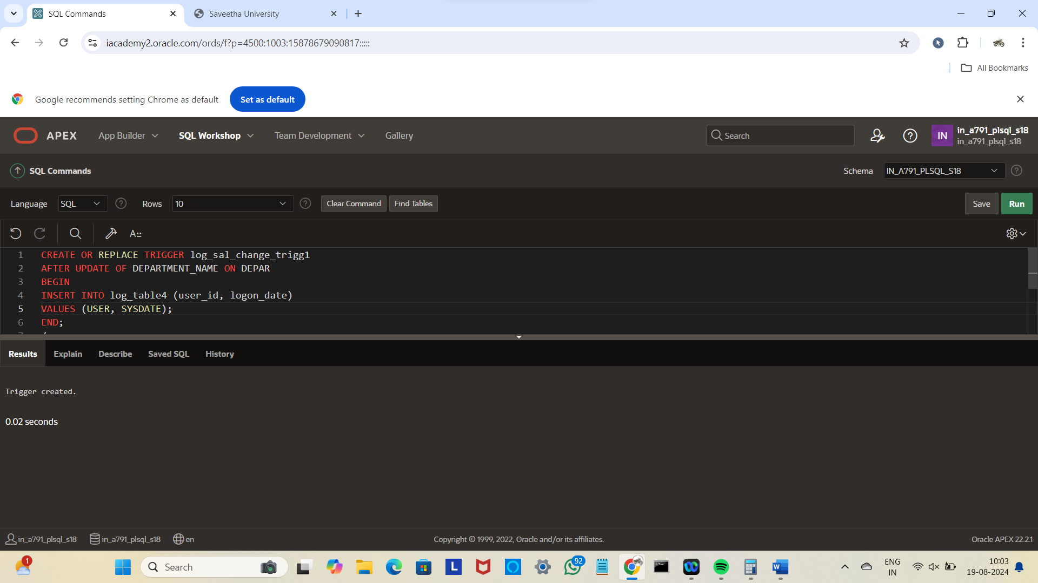

UPDATE DEPAR SET DEPARTMENT_NAME='ECE' WHERE DEPARTMENT_NAME='CSE';

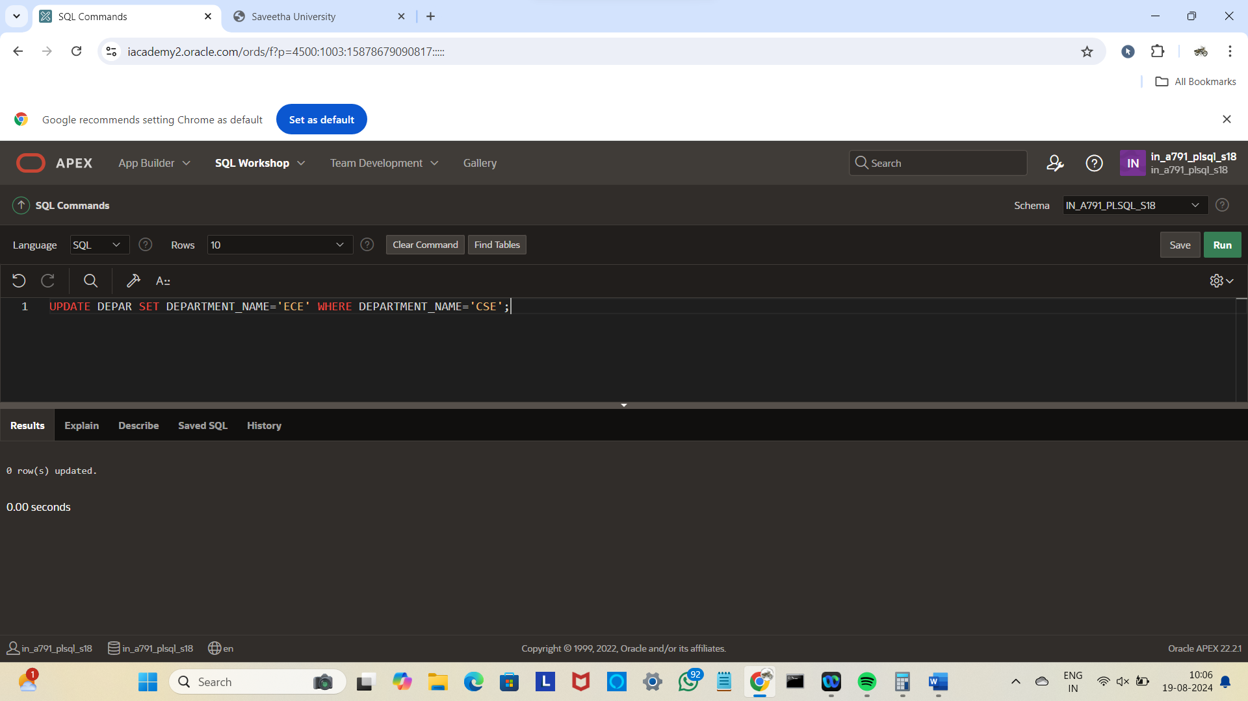

SELECT *FROM log_table4;

